**TECHNICAL REPORT WRITING FOR CA#2 EXAMINATION**



**NAME**- SAPNADARSHI SINGHA

**STREAM**- COMPUTER SCIENCE AND BUSINESS SYSTEM

**YEAR**- SECOND (FOURTH SEMESTER)

**ROLL NUMBER**- 18731122014

**SUBJECT NAME**- INTRODUCTION TO INNOVATION, IP MANAGEMENT & ENTREPRENEURSHIP

**SUBJECT CODE-** HSMC 401

**REGISTRATION NO**- 221870110095

**DATE OF SUBMISSION**- 17/03/2024

**TOPIC- MANAGEMENT & CREATING NEW PRODUCTS AND SERVICES EXPLOITING OPEN INNOVATION AND COLLABORATION**

**TABLE OF CONTENT**

|  |  |  |
| --- | --- | --- |
| SI NO. | CONTENT | PAGE NO |
|  | TABLE OF CONTENT | 2 |
|  | ABSTRACT | 3 |
|  | INTRODUCTION | 4 |
|  | ANALYSIS | 5-9 |
|  | CONCLUSION | 10 |
|  | REFERENCE & PLAGIRISM | 11 |

**TABLE OF DIAGRAM**

|  |  |  |
| --- | --- | --- |
| SI NO. | DIAGRAMS | PAGE |
| 1 | DIAGRAM 1(Functions of Management) | 4 |
| 2 | DIAGRAM 2(Challenges in Open Innovation) | 5 |
| 3 | DIAGRAM 3(Plagiarism check report) | 11 |

ABSTRACT

This abstract investigates the incorporation of open innovation and collaboration into management practices to promote the development of new products and services. It emphasizes the importance of expanding beyond traditional closed boundaries in order to leverage external expertise and resources. It explains the principles, challenges, and management strategies involved by drawing on current literature and case study examples. It also highlights emerging trends like crowdsourcing and digital platforms, emphasizing the transformative power of open innovation ecosystems. Finally, the abstract advocates for a strategic management approach that values collaboration, allowing organizations to drive innovation and remain competitive in dynamic markets.

INTRODUCTION

Organizations face enormous pressure to innovate on a continuous basis in today's rapidly changing business landscape, which is characterized by technological disruptions, changing consumer preferences, and increased global competition. Traditional innovation models, which rely solely on internal R&D and closed organizational boundaries, are increasingly inadequate in meeting the complexities and demands of today's market. As a result, organizations seeking to thrive in the face of uncertainty and complexity must embrace a paradigm shift toward open innovation and collaboration.

Open innovation is more than just inbound or outbound technology transfer; it is a comprehensive approach to innovation management that involves collaborating with a wide range of stakeholders, including customers, suppliers, academia, and even competitors, to co-create value.   
  
Similarly, collaboration has emerged as a driving force behind innovation, allowing organizations to pool resources, share risks, and leverage complementary capabilities. Collaborative innovation goes beyond traditional partnerships to include ecosystems in which multiple actors work together in a networked environment to address complex challenges and seize emerging opportunities. In essence, collaboration promotes synergies among participants, thereby increasing their collective capacity for innovation and market success.

Furthermore, open innovation and collaboration allow organizations to reduce the risks associated with traditional innovation approaches. Organizations can reduce the burden of R&D investments by distributing innovation efforts across a network of partners, while also improving their ability to adapt to changing market conditions. This distributed innovation model promotes agility and resilience, enabling organizations to better navigate uncertainties and seize emerging opportunities.

ANALYSIS

**MANAGEMENT**

Management is the process of planning, organizing, staffing, directing, and controlling resources (people, finances, materials, and time) in order to achieve the needed goal in an effective and efficient manner. It involves coordinating the efforts of people to accomplish common objectives and ensuring that resources are used wisely to maximize productivity.

Here are the various types of management, each focusing on different aspects of an organization:

1. **Strategic Management**: This type of management entails establishing long-term goals and objectives for the organization, developing strategies to achieve them, and allocating resources appropriately. Strategic management entails analysing the external environment and making decisions that are consistent with the organization's mission and vision.
2. **Operational Management**: Operational management focuses on an organization's day-to-day activities. It entails managing resources, processes, and systems to ensure smooth operations and efficient production of goods and services. Operations managers are in charge of scheduling, quality control, and inventory management.
3. **Quality Management**: Quality management aims to ensure that products or services meet or exceed customer expectations. This includes establishing quality standards, putting in place quality control processes, and promoting continuous improvement. Quality managers aim to consistently provide high-quality products or services.
4. **Marketing Management:** Marketing management is concerned with identifying and meeting customer needs and wants through the development and implementation of marketing strategies. This encompasses market research, product development, pricing, promotion, and distribution. Marketing managers strive to provide value to customers while also generating revenue for their organizations.
5. **Financial Management:** Financial management is the process of managing an organization's finances in order to achieve its goals. This includes budgeting, financial planning, making investment decisions, and managing cash flow. Financial managers strive to improve the organization's financial performance while ensuring its long-term financial stability.

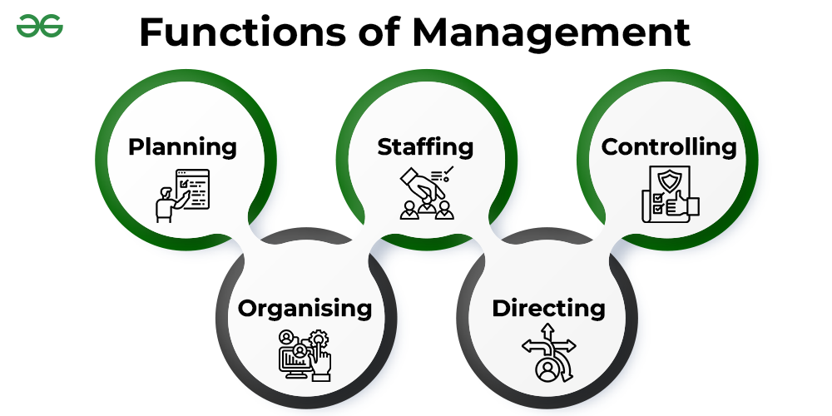

**CREATING NEW PRODUCTS AND SERVICES**

Creating new products and services are essential aspects of strategic management and innovation management within organizations. It involves the development and introduction of novel offerings that address the evolving needs and preferences of customers. Here's an introduction to the process of creating new products and services:

1. OPPORTUNITIES IDENTIFICATION:

The process begins with identifying market or internal opportunities. This could include analysing consumer trends, conducting market research, investigating competitor offerings or Any problem statement in market.

1. IDEA GENERATION:

Once opportunities have been identified, the next step is to brainstorm ideas for new products or services. This can be accomplished through brainstorming sessions, idea competitions, customer surveys, or by tapping into employees' creativity.

1. IDEA DISCUSSION:

Before starting the work on idea, first we have to consult any authority or persons to discuss the feasibility of the idea to find out if the idea is valid or promising. If the idea is promising enough and have vision then market analysis must be done to find out if the success of the product is possible or not. Apart from that Scalability and Feasibility of the product must be calculated before starting production of the idea.

1. PRODUCT DEVELOPMENT:

Once opportunities have been identified, the next step is to generate concepts for new products or services. This can be accomplished through brainstorming sessions, idea competitions, customer surveys, or leveraging employees' creativity. After Production is complete the Value for the product must be set before launching.

1. TESTING:

Before releasing a product or service to the market, it is rigorously tested and validated to ensure that it meets customer needs and performs as intended. This can include alpha and beta testing, focus groups, usability studies, and market trials.

1. LAUNCHING:

After testing is done all the probable issues and bugs must be removed. Then product is ready to launch in the market. Accurate marketing of the product must be done in order to achieve the initial boost of the product.

1. CONTINIOUS EVALUATION AND IMPROVEMENT:

After Launching proper evolution must be done in order to increase the efficiency. Customer’s feedback is very important in this. Organizations must constantly iterate and improve their products and services in order to remain competitive and meet changing customer demands. This includes gathering feedback, monitoring market trends, and investing in R&D.

**EXPLOITING OPEN INNOVATION AND COLLABORATION**

*Open innovation* is a concept in which companies can and should use both internal and external ideas and market paths to advance their technology. Unlike traditional closed innovation models, which develop ideas internally and keep them within the organization, open innovation promotes collaboration with external partners such as customers, suppliers, universities, and even competitors to accelerate innovation.

*Collaboration* is the process by which individuals or groups work together to achieve a common goal or objective. It entails exchanging ideas, resources, responsibilities, and expertise in order to solve problems, make decisions, and add value. Collaboration can take place within teams, across departments, between organizations, or with external stakeholders like customers, suppliers, or partners. Here are some important aspects of collaboration:

There are some key aspects of Open innovation which is dependent on Collaboration:

* Organizations frequently use collaborative platforms and networks to promote open innovation. These platforms facilitate the exchange of ideas, knowledge, and resources between internal teams and external partners.
* Open innovation is the practice of leveraging external sources of ideas, technologies, and expertise to boost internal innovation within an organization. It entails collaborating with external partners such as customers, suppliers, universities, research institutions, and even competitors to jointly create value.
* Establishing strategic partnerships with other organizations can provide access to complementary resources, expertise, and market opportunities. Collaboration with partners enables organizations to leverage one another's strengths and accelerate innovation.
* Instead of keeping innovations proprietary, open innovation promotes the exchange of ideas, technologies, and knowledge with external partners. Companies can accelerate innovation while lowering R&D costs by sharing and leveraging external knowledge.
* Other important Aspects of Open Innovation:
* **Intellectual Property (IP) Management**:

Companies that practice open innovation use flexible intellectual property strategies to protect their core technologies while also sharing and licensing non-core technologies with external partners. This approach enables businesses to monetize their intellectual property assets while encouraging collaboration and innovation.

* **Continuous Learning and modifying:**

Open innovation necessitates a culture of continuous learning and adaptation, in which businesses are willing to experiment with new approaches, learn from mistakes, and adjust their strategies in response to feedback and market dynamics. This iterative approach allows companies to remain agile and responsive to changing market conditions.

* **CHALLENGES IN OPEN INNOVATION:** Every field has its own challenges, so does open innovation. Here are some Drawbacks in Open Innovation

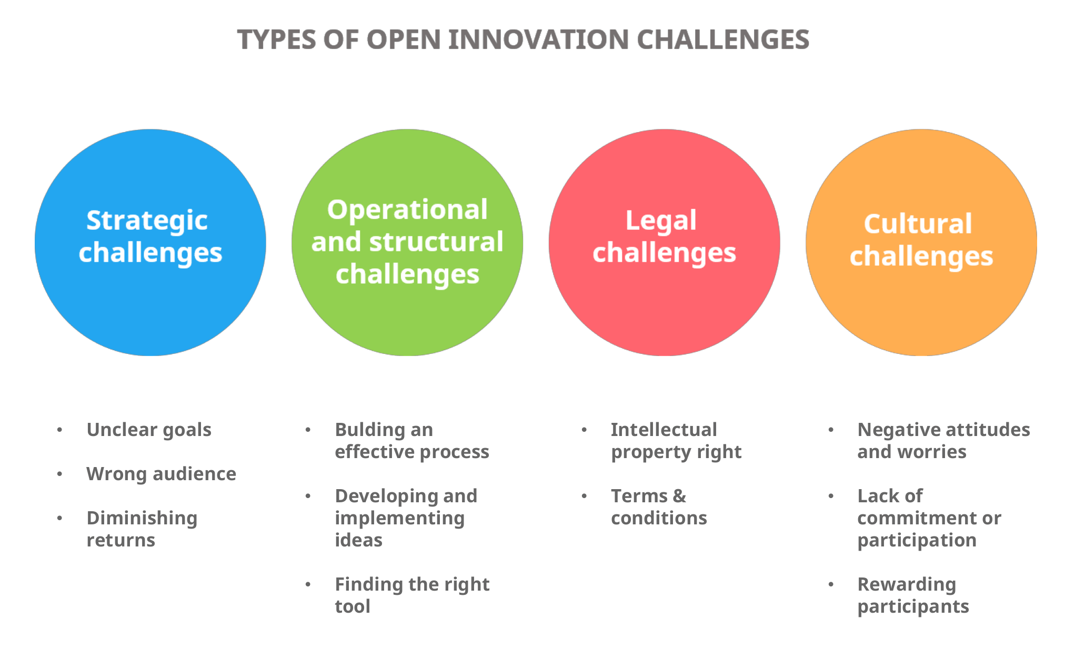

**CONCLUSION**

Finally, effective management is critical for organizations to achieve their goals efficiently and successfully in today's dynamic business environment. Management includes a variety of functions such as strategic planning, operational coordination, financial oversight, human resource management, marketing, quality assurance, and IT management. Organizations can optimize resource allocation, reduce risks, seize opportunities, and drive long-term growth by implementing appropriate management practices.

Developing new products and services is critical for businesses to innovate, remain competitive, and meet changing customer demands. This process entails identifying opportunities, brainstorming ideas, screening concepts, conducting market research, creating and testing prototypes, and commercializing offerings. Exploiting open innovation and collaboration is critical in this process because it allows organizations to leverage external expertise, resources, and ideas to accelerate innovation and create value. Collaboration with customers, suppliers, partners, and even competitors allow organizations to leverage collective insights, capabilities, and networks to develop breakthrough innovations, improve product quality, and increase market responsiveness.

To summarize, effective management practices, combined with a focus on developing new products and services through open innovation and collaboration, are required for organizations to thrive in today's rapidly changing business environment. Organizations can drive long-term value for stakeholders by embracing innovation, leveraging external partnerships, and cultivating a collaborative culture.

* **REFERENCES:**

1. **Diagrams-** [**https://www.geeksforgeeks.org/**](https://www.geeksforgeeks.org/) **,** [**https://www.stretchinnovation.be/**](https://www.stretchinnovation.be/)
2. [**https://www.coursera.org/articles/management**](https://www.coursera.org/articles/management)
3. [**https://link.springer.com/referenceworkentry/10.1007/978-1-4614-3858-8_500**](https://link.springer.com/referenceworkentry/10.1007/978-1-4614-3858-8_500)
4. [**https://www.ifm.eng.cam.ac.uk/uploads/Resources/Reports/OI_Report.pdf**](https://www.ifm.eng.cam.ac.uk/uploads/Resources/Reports/OI_Report.pdf)

* **Plagiarism check report:**

